

**BMS COLLEGE OF ENGINEERING,**

**Bangalore-560019**

Department

Of

Computer Science and Engineering

Course: Database Management Systems

Course code:21CS3PCDBM

Submitted To,

Dr. Manjunath D R

Assistant Professor

Department of Computer Science and Engineering

Submitted By,

Name- Shivani Sathyanarayanan

USN- 1BM21CS203

SECTION D

**SQL CODE:**

create database insurance;

use insurance;

create table person(driver_id varchar(10)primary key,name varchar(20),address varchar(20));

desc person;

create table car(reg_num varchar(10)primary key,model varchar(10),year int);

create table accident(report_num int primary key,accident_date date,location varchar(20));

create table owns(driver_id varchar(10),reg_num varchar(10),primary key(driver_id,reg_num));

drop table owns;

create table owns(driver_id varchar(10),reg_num varchar(10),primary key(driver_id,reg_num));

drop table owns;

create table owns(driver_id varchar(10),reg_num varchar(10),primary key(driver_id,reg_num),

foreign key(driver_id) references person(driver_id),foreign key(reg_num) references car(reg_num));

create table participate(driver_id varchar(10),reg_num varchar(10),report_num int,damage_amount int,

primary key(driver_id,reg_num,report_num), foreign key(driver_id) references person(driver_id),

foreign key(reg_num) references car(reg_num),foreign key(report_num) references accident(report_num));

insert into person values('A01','Richard','Srinivas Nagar'),('A02','Pradeep','Rajaji nagar'),

('A03','Smith','Ashok nagar'),('A04','Venu','N R Colony'),('A05','Jhon','Hanumanth nagar');

insert into car values('KA052250','Indica','1990'),('KA031181','Lancer','1957'),

('KA095477','Toyota','1998'),('KA053408','Honda','2008'),('KA041702','Audi','2005');

insert into accident values(11,'2003-01-01','Mysore road'),(12,'2004-02-02','South end circle'),

(13,'2003-01-21','Bull temple road'),(14,'2008-02-17','Mysore road'),(15,'2005-03-04','Kanakapura road');

insert into owns values('A01','KA052250'),('A02','KA053408'),

('A03','KA031181'),('A04','KA095477'),('A05','KA041702');

insert into participate values('A01','KA052250',11,10000),('A02','KA053408',12,50000),

('A03','KA095477',13,25000),('A04','KA031181',14,3000),('A05','KA041702',15,5000);

update participate set damage_amount=25000 where reg_num='KA053408' AND report_num=12;

select *

from participate;

insert into accident values(16,'2008-03-08','Domlur');

select*

from accident;

select accident_date,location

from accident;

select driver_id

from participate

where damage_amount>=25000;

select *

from person

where name like 's%';

select driver_id,report_num

from participate

where report_num in(11,14,15);

select *

from car

where model not in('Audi','Lancer','Toyota');

select *

from accident

where accident_date>='2003-01-01' and accident_date<='2003-01-31';

select *

from accident

where location like'm%' or location like'%d';

select *

from person

where driver_id between 'A02' and 'A04';

select damage_amount+1000 from participate;

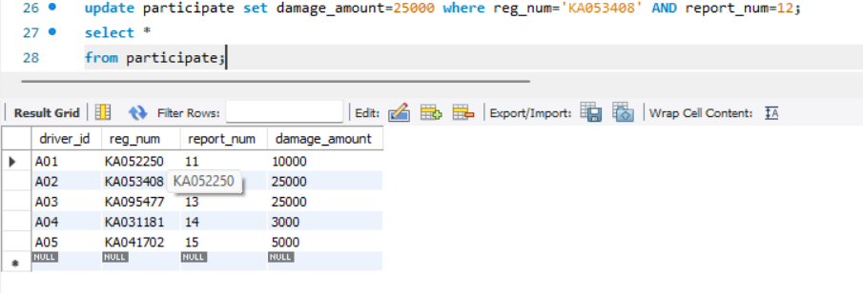**OUTPUTS:**

